SELECT with various clause – BETWEEN, IN, Aggregate function

Questions:
IN & BETWEEN
- List the type of the courses “Statistics” and “Programming”
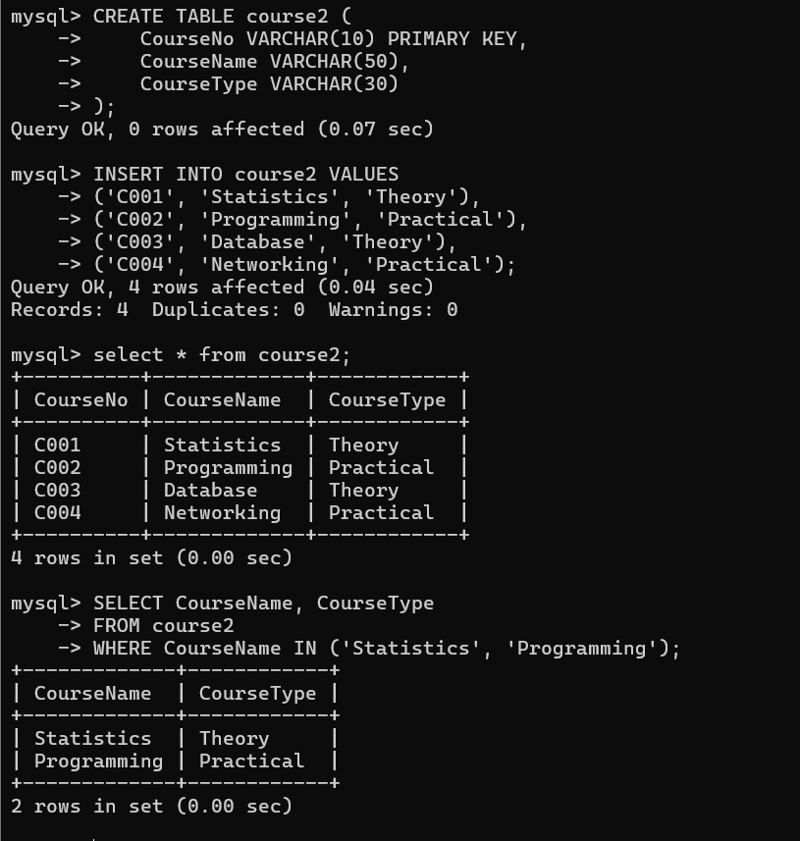
- The instructor wants to know the CourseNos whose scores are in the range 50 to 80
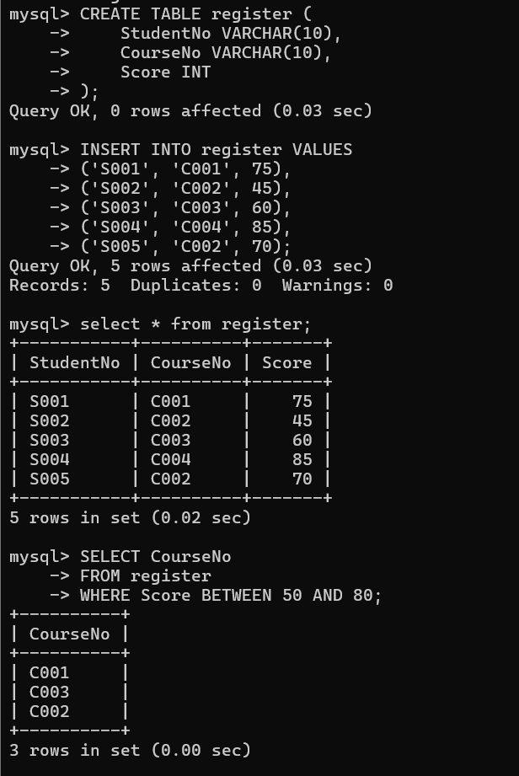
AGGREGATE
- Find the average mark of “C002”.
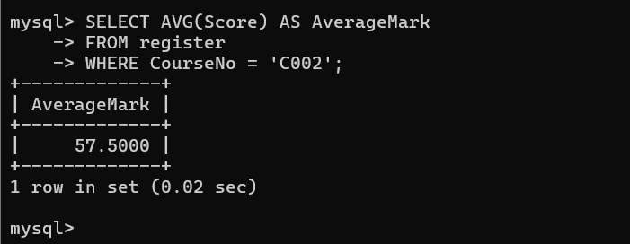
- List the maximum, minimum mark for “C002”
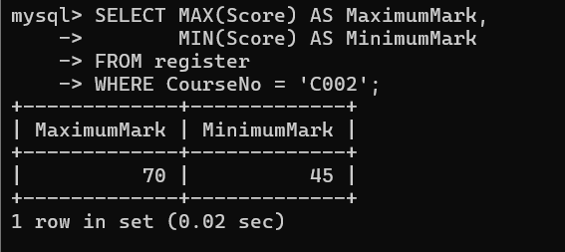
- List the maximum, minimum, average mark for each course
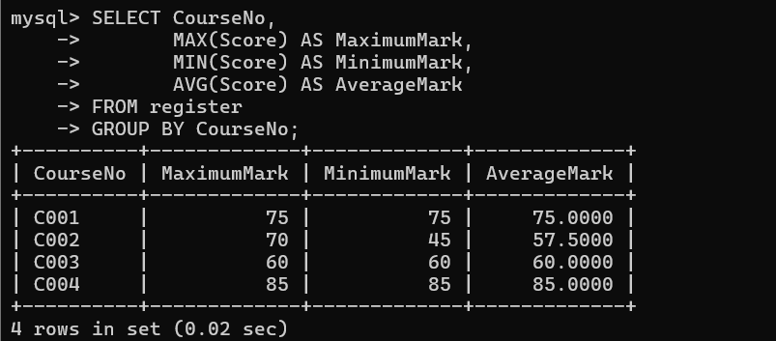
- List the name of the courses and average mark of each course.
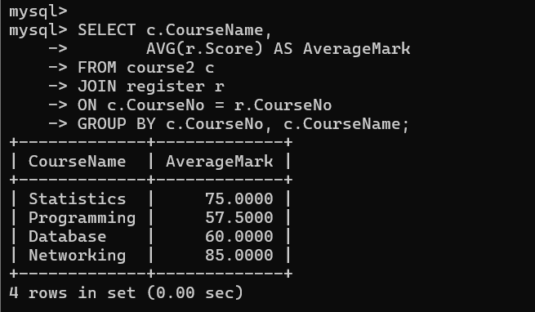
- Calculate the sum of all the scores.
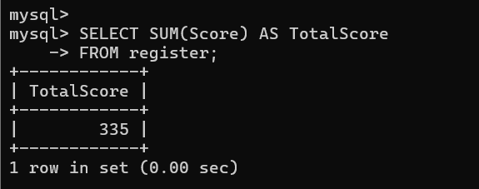
- How many students are registered for each course? Display the course description and the number of students registered in each course.
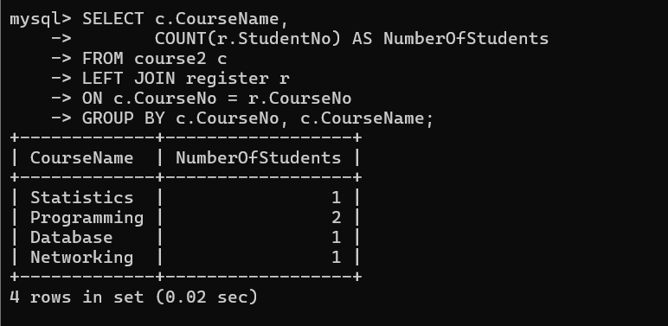
- How many courses did each student register for?
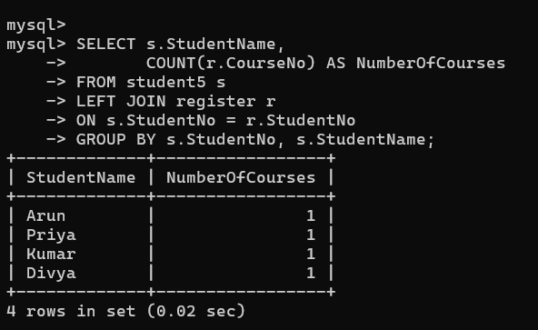

RESULT:
The records from the tables are displayed using SELECT commands with WHERE Clause and Pattern matching.

